Module 3- Activities
Unit 1: TEST
- Activity 1- Cartoon and quiz questions

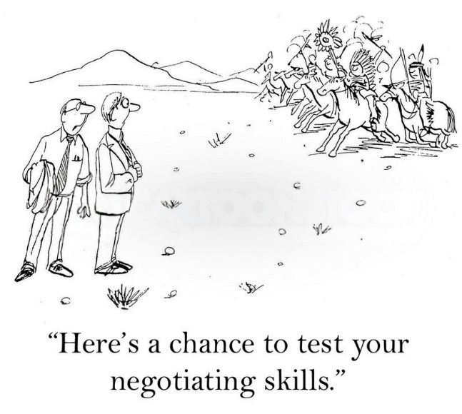

Look at the cartoon picture by cartoonist Andrew Toos and answer the following questions (correct answers provided in bold).

1. What is the main situation depicted in the cartoon?
A. TEST2
B. TEST
C. TEST3
D. TEST4

2. The caption says, “Here’s a chance to test your negotiating skills.” What is the humor in this statement?
A. TEST4
B. TEST3
C. TEST2
D. TEST

- Activity 3, Part I- Crossword Puzzle: Oral intercultural communication strategies

Clues:
Across
- Listening carefully and asking questions to show understanding (2 words)
ACTIVE LISTENING
- Adjusting your style of speaking to fit cultural preferences (1 word)
ADAPT
- Avoiding complex words or slang for clarity to keep your message clear and _______. (1 word)
SIMPLE

Down
2. Awareness of gestures, expressions, and posture (3 words)
NON-VERBAL COMMUNICATION
3. Learning about different cultural customs (2 words)
CULTURAL AWARENESS
5. Responding with consideration, helps you be _________ of your co-speakers (2 words)
THOUGHTFUL

